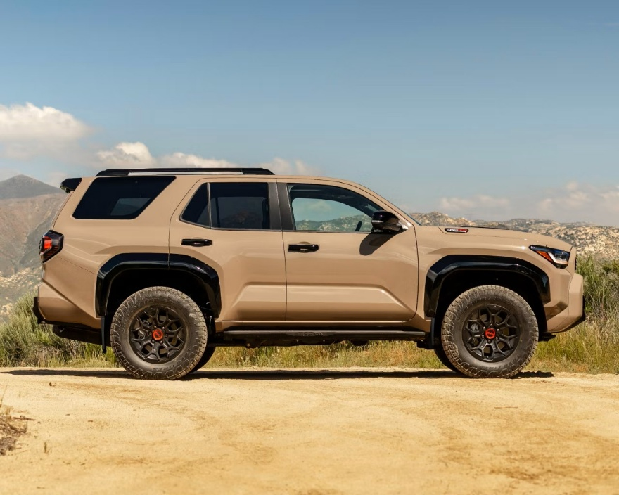

New Suspension System Design for the 5th Gen Toyota 4Runner
  - Lightweight, affordable and latest suspension system
Micah Haile | Machine Dynamics 380 | November 2025

New Suspension System Design for the 5th Gen Toyota 4Runner
A technical report with a detailed study into a suspension system that closely resembles the 4Runner’s suspension system, and a new design considering ideally smooth car ride experience.

Prepared For
Nikolay Bukharin, PhD
Prepared by
Mechanical Engineering Technology Department
Southern Alberta Institute of Technology
Author
Micah Haile, MET Student

Executive Summary
This report presents an analytical study of a vehicle suspension system representative of the 5th generation Toyota 4Runner, with the primary objective of evaluating ride comfort and dynamic response under realistic low-speed urban driving conditions. The suspension system is modeled using a single-degree-of-freedom (SDOF) quarter-car model, representing one corner of the vehicle as an equivalent mass–spring–damper system.
Due to the lack of publicly available manufacturer specifications for spring stiffness and damping characteristics, suspension parameters are adopted from experimentally identified data for comparable mid-size SUVs reported. The model uses a suspension spring stiffness of $k=3.0×{10}^{4}\text{ N/m}$and a constant damping ratio of $ζ=0.35$, selected as a realistic compromise between ride comfort and handling performance. This damping ratio lies within commonly accepted ranges for passenger vehicles and SUVs. Tire stiffness and damping are neglected, and the tire is assumed rigid so that all vertical compliance is attributed to the suspension system. Numerical simulations are performed using GNU Octave.
Two operating scenarios are investigated. The first considers the vehicle traveling at a conservative speed of 20 km/h on an icy roadway within an Alberta school zone, where the road surface is modeled as a minor periodic irregularity with a vertical base excitation amplitude of 0.005 m. The second scenario evaluates the suspension response to a rubber speed bump with a height of 0.10 m and a length of 0.35 m, representative of commonly installed speed-control devices. The suspension response is assessed in terms of displacement transmissibility, oscillations, and settling behavior.
Under smooth-road conditions, the transmitted body displacement remains small, indicating acceptable ride comfort. When subjected to the speed bump excitation, the vehicle body response decays to negligible oscillations within approximately 2 seconds, demonstrating stable dynamic behavior and adequate damping. This settling time is consistent with expectations for a well-tuned mid-size SUV suspension operating at low speed.
Overall, the results show that the selected suspension parameters produce a stable and comfortable ride while maintaining reasonable dynamic control. Although simplified, the quarter-car model provides meaningful insight into suspension performance.

Table of Contents
Executive Summary ii
Introduction 1
Purpose and Scope 1
Background 1
Research Methods 1
Assumptions 1
Stock Suspension Analysis: Vehicle Traveling on an uneven road 1
Stock Suspension Analysis: Simulating a Speed Bump 2
Stock Suspension Analysis: Simulating a Pit 2
Conclusion and Recommendations 3
Appendix 1
Appendix A – Suspension Calculations 1
Appendix B – Octave Code for Simulations 2
References 1
Credits / Acknowledgements 1

Introduction
This technical report provides a new vehicle suspension system design for the 5th generation Toyota 4Runner. This suspension system is designed using stiffness and damping coefficients from a closely similar vehicle setup.

Purpose and Scope
The purpose of this project is to design a suspension system capable of achieving a comfortable ride. A suspension modeled after a 4Runner front corner. To develop this study, we will focus on one Tire, one suspension system, quarter of the mass of the 4Runner. This report includes a mathematical model of the suspension system using Octave Software, characteristics of the suspension system in terms of stiffness and damping coefficient, analysis of the suspension system’s behavior while the vehicle is traveling on a smooth road as well as while its traveling on a bump. This project does not include studies done under multiple degrees of freedom assumption or a free hand sketch.

Background
The Toyota 4Runner is an SUV manufactured by the Japanese automaker Toyota and marketed globally since 1984, across six generations [1]. A majestic looking, capable vehicle adored by many. The Toyota 4Runner was selected as the focus of this study due to personal interest in the vehicle and are explained in great detail in the Credit/Acknowledgment section of this paper. Though 6 generations exist in the market, the 5th generation was selected for this new suspension design project since it’s widely available, reliable and has modern suspension data from owners.

Research Methods
Research methods done in this project are entirely secondary research. Vehicle Dynamics textbooks are referenced, and Computer Aided designs are utilized to better understand the system. To provide numerical studies, programing language Octave is utilized. Because Toyota does not publish spring‐rate specifications, values are based on experimentally identified parameters for a mid-size SUV with comparable mass and suspension layout, which closely resembles a Toyota 4Runner.

Assumptions
The vehicle is modeled using a single-degree-of-freedom (SDOF) quarter-car model consisting of:
- Equivalent sprung mass m
- Suspension spring stiffness k
- Suspension damping coefficient c
The suspension represents a mid-size, body-on-frame SUV with:
- Independent front suspension
- Solid rear axle
- Vehicle type comparable to a Toyota 4Runner
Suspension parameters are adopted from experimentally identified data for comparable mid-size SUVs reported in [2].
Based on source [2], the quarter-car suspension spring stiffness is:
$$k=3.0×{10}^{4} N/m$$
Since best ride comfort occurs near ζ ≈ 0.2, best handling occurs near ζ ≈ 0.8, A constant damping ratio of ζ=0.35 is assumed. These values illustrate the comfort–handling trade-off [2].
The selected damping ratio ζ = 0.35:
- Lies within the commonly reported passenger-vehicle range of 0.2–0.4.
- Represents a realistic compromise between comfort and handling for an SUV.
- Is considered representative of a Toyota 4Runner-style suspension
Tire stiffness and damping are neglected for modeling simplicity:
- The tire is treated as rigid
- All vertical compliance is attributed to the suspension spring and damper
The vehicle is assumed to operate on an icy roadway in Alberta within a school zone during regulated hours (8:00 a.m. to 9:30 p.m.) [3]. The posted maximum speed limit is 30 km/h.
For safety-focused analysis, the vehicle speed is assumed to be 20 km/h.
No-speed-bump case:
- Road surface modeled as minor periodic surface irregularities
- Base excitation amplitude: 0.005 m
- Represents uneven pavement typical of icy road conditions
- Surface irregularities are assumed to occur every 3 m
Speed-bump case:
- A low-cost rubber speed bump is assumed
- Bump height: 0.10 m
- Bump length (direction of travel): 0.35 m
- Dimensions are consistent with commercially available rubber speed-control pads [5].

Stock Suspension Analysis: Vehicle Traveling on an uneven road
In the Purpose and Scope of this report, we’ve established that this report analyzes a singular suspension system with quarter of the mass of the 5th gen Toyota 4Runner. To model this vehicle, we’ll use a mechanical vibration diagram with the vehicle’s mass [m] and the suspension system into an equivalent spring constant [k] produced by the suspension coils as well as a damping constant [c] produced by the shock absorber.
To provide numerical solutions, the mass [m], Stiffness coefficient [k], Damping Coefficient [c], Natural Frequency [$ω_{n}$], and road-input [Y] are required.
The 5th generation Toyota 4Runner’s curb weight is approximately 2,000 kg. Since this report is done on one suspension system, quarter of the mass is utilized.
Since we already have the Spring Coefficient and dumping ratio, we can calculate natural frequency and damping coefficient using our values:
$m=500\text{ kg}$ $k=3.0×{10}^{4} \text{N/m}$ ζ = 0.35
Appendix A consists of formulas and equations to solve the Natural Frequency of the vehicle, Damping Coefficient of the shock absorber, the forcing frequency, the frequency ratio between the Forcing Frequency and the Vehicle’s Natural Frequency and Ratio of Transmissibility.
This way, we’ve successfully concluded that a 5 mm amplitude on the road will be transmitted as a 5.73 mm to the vehicle chassis.
Let’s simulate the mass–spring–damper system with base excitation.
$$m\ddot{x}+c(\dot{x}-\dot{y}​)+k(x-y)=0$$
$$y(t)=Y\sin\left(ωt\right) \dot{ y}(t)=Yωcos⁡(ωt)$$
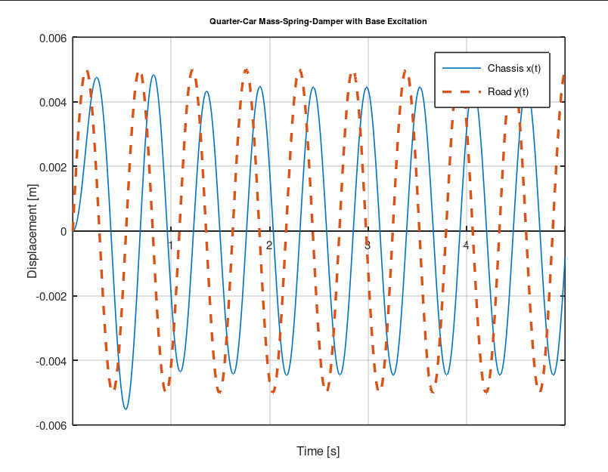
Figure 1: Vehicle Displacement vs Time

Stock Suspension Analysis: Simulating a Speed Bump
The simulated response was that the vehicle body displacement becomes negligible after about 2 s following the disturbance caused by a speed bump shown in Figure 1. Vehicle had an initial Y displacement of 0.1 m and was travelling at 20 km/hr.
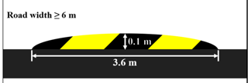
Figure 2: Speed Bump Cross section
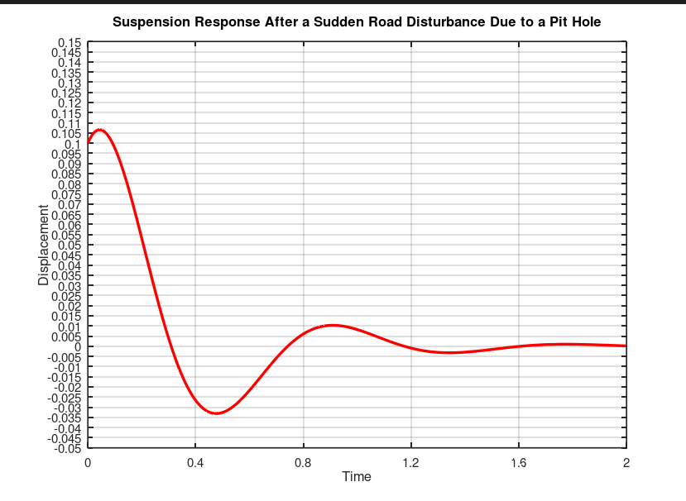

Stock Suspension Analysis: Simulating a Pit
Pit analysis was performed under the assumption that the vehicle was traveling from the deep pit, 0.1m below a normal road surface. Initial conditions were a Y displacement of -0.1 meters and vehicle was traveling at 20 km/hr. What was noticed was that the vehicle stabilized and went into the vehicle’s natural frequency after about 2 seconds.
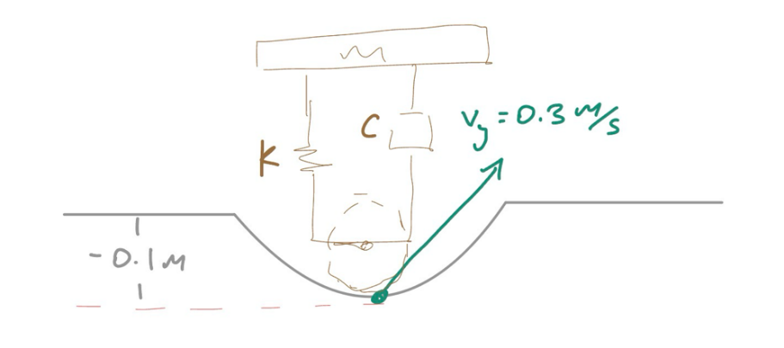
Figure 3: Pit Simulation
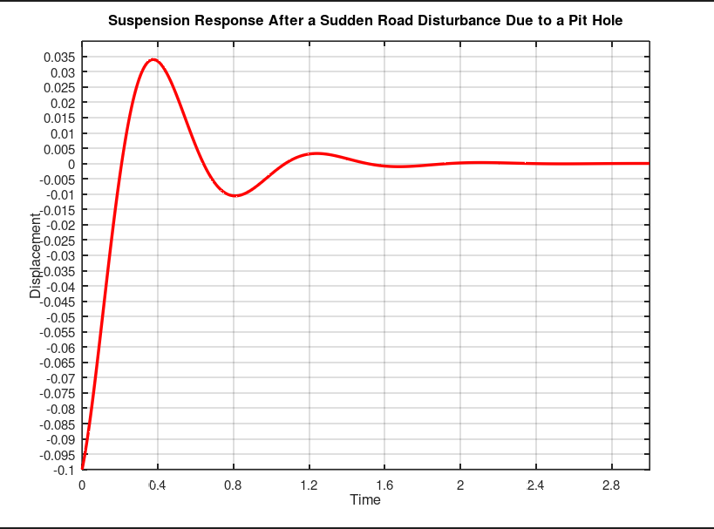
Figure 4: Suspension response after disturbance due to pit hole

Conclusion and Recommendations
This project investigated vehicle suspension performance through reverse engineering, with user comfort as the primary design objective. To improve ride quality, a reduced damping ratio and lower spring stiffness were selected, resulting in a lower natural frequency of the suspension system. A lower natural frequency reduces the transmission of road-induced vibrations to the vehicle chassis, contributing to a smoother ride experience.
Due to the absence of publicly available suspension data for the Toyota 4Runner, identifying appropriate spring and damping coefficients presented a significant challenge. Comparable vehicle data was therefore used to estimate realistic parameters. The resulting suspension configuration achieved a transmissibility of approximately 14%, with a chassis displacement of 0.0057 m in response to a 0.005 m road surface variation. Following a bump or pit disturbance, the system returned to steady-state behavior within approximately 2 seconds, indicating acceptable damping performance for ride comfort.
Further improvements to this study could be achieved by extending the analysis to a multi-degree-of-freedom suspension model to better capture real vehicle dynamics. Access to manufacturer-provided suspension parameters would increase model accuracy, and incorporating CAD-based dynamic simulations would provide more intuitive visualization compared to time-response plots generated in Octave.

Appendix

Appendix A – Suspension Calculations
- Natural frequency:
$$ω_{n}=\sqrt{\frac{k}{m}}=\sqrt{\frac{3.0×{10}^{4}}{500}}≈7.75\text{ rad/s}$$
- Damping coefficient:
$$c=2ζ\sqrt{km}=2(0.35)\sqrt{\left(3.0×{10}^{4})(500\right)}≈2.7×{10}^{3}\text{ N.s/m}$$
- Forcing frequency due to road excitation:
$$ω=\frac{2πv}{λ}≈11.6\text{ rad/s}$$
- Frequency ratio:
$$r=\frac{ω}{ω_{n}}=1.502$$
- Displacement transmissibility (base excitation):
$$\frac{X}{Y}={\left[\frac{1+(2ζr)^{2}}{\left(1-r^{2})^{2}+(2ζr)^{2}\right.}\right]}^{1/2}=1.14$$
- Vehicle displacement:
$$Y=0.005\text{ m}⇒X=1.14(0.005)=0.00573\text{ m}$$

Appendix B – Octave Code for Simulations

clear;
function damped=f(x,t)
m=500;
k=30000;
c=2700;
Y = 0.00;
w = 5.82;
damped=zeros(2,1);
damped(1)=x(2);
damped(2)= (-c/m)*x(2)-(k/m)*x(1)+(k*Y/m)*sin(w*t)+(c*w*Y/m)*cos(w*t);
endfunction

t=linspace(0,3,1000);
x0=[-.10; .31];
y=lsode("f",x0,t);

plot(t,y(:,1),'LineWidth', 1, 'r');

yticks(-0.1:0.005:0.15);
xticks(0:0.4:5);

xlabel("Time")
ylabel("Displacement")
title("Suspension Response After a Sudden Road Disturbance Due to a Pit Hole");

grid on

References

[1] | W. Contributors, "Toyota 4Runner," Wikipedia, The Free Encyclopedia., 28 November 2025. [Online]. Available: https://en.wikipedia.org/w/index.php?title=Toyota_4Runner&oldid=1324636632. [Accessed 28 November 2025].
[2] | J. C. Dixon, The Shock Absorber Handbook, Chichester: John Wiley & Sons, 2007.
[3] | G. o. Alberta, "School and Playground Zones," Government of Alberta, n.d.. [Online]. Available: https://www.alberta.ca/school-and-playground-zones. [Accessed 02 12 2025].
[4] | D. L. M. William F. Milliken, William F. Milliken, Douglas L. Milliken, SAE International, 1995.
[5] | J. Y. Wong, Theory of Ground Vehicles, John Wiley & Sons, 2008.
[6] | T. D. Gillespie, Fundamentals of Vehicle Dynamics, SAE International, 1992.
[7] | C. Crivellaro and D. C. Donha, "Fast Experimental Identification of Suspension Models for Control Design," Proceedings of the Institution of Mechanical Engineers, Part D: Journal of Automobile Engineering, vol. 255, no. D, pp. 609-626, 2011.
[8] | Amazon.ca, "Rubber Speed Bump Car Speed Limit Pad, School and Community Gate Toll Station Ramp Deceleration Buffer Area, Ground Groove (H50 mm)," Amazon.ca, n... [Online]. Available: https://www.amazon.ca/Rubber-School-Community-Station-Deceleration/dp/B09CMSRP55. [Accessed 02 December 2025].
[9] | M. Otkur, A. M. Akünal and S. Aydın, "Optimization of Suspension System Parameters for a SUV," MCM 2022 Proceedings, pp. 76-83, 2022.
[10] | M. Doss, "Speed Bump - Standard," dimensions.com, 11 June 2023. [Online]. Available: https://www.dimensions.com/element/speed-bump-standard. [Accessed 11 December 2025].

Credits / Acknowledgements
I would like to acknowledge the personal support and encouragement received throughout the completion of this project. Special recognition is given to my girlfriend, whose interest in the Toyota 4Runner initially inspired the selection of the vehicle for this study and whose continued encouragement provided motivation during the research and analysis process.
Additional acknowledgement is extended to the instructional support provided through the Mechanical Engineering Technology program at SAIT, as well as the authors of the referenced vehicle dynamics literature that informed the modeling assumptions and analytical approach used in this report.

